TBS
Architecture Notebook

Initial Class Diagram

The class diagram is the main building block of object-oriented modeling. It is used for general conceptual modeling of the structure of the application, and for detailed modeling, translating the models into programming code. Class diagrams can also be used for data modeling.
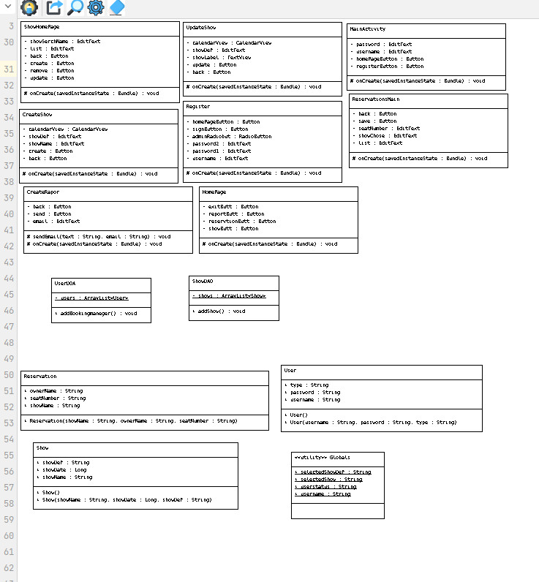

Package Diagram

Package diagrams are most commonly used to provide a visual organization of the layered architecture within any UML classifier, such as a software system.

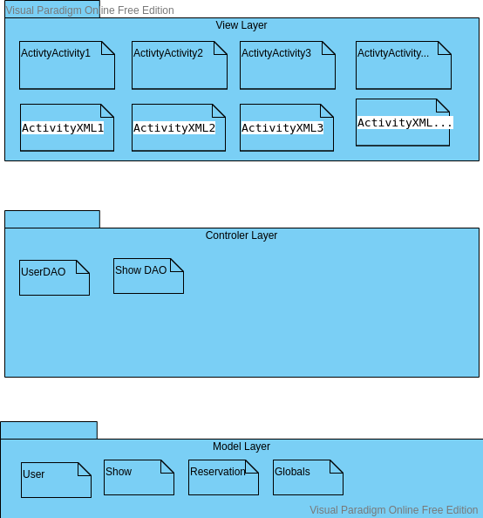

Component Diagram

A component diagram, also known as a UML component diagram, describes the organization and wiring of the physical components in a system. Component diagrams are often drawn to help model implementation details and double-check that every aspect of the system's required functions is covered by planned development.

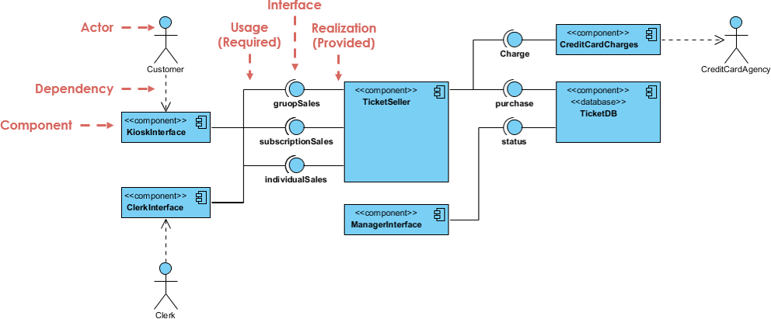

Deployment Diagram

Deployment diagram is a UML diagram type that shows the execution architecture of a system, including nodes such as hardware or software execution environments, and the middle ware connecting them. Deployment diagrams are typically used to visualize the physical hardware and software of a system.
